Submitted the project as partial fulfilment for Advanced Excel completion requirements.

Submitted by:

***Parul Sharma***

On (13-02-2025)

Under the supervision of:

***Nikhil Rana***

# 

# List of Figures

Figure 1 - Sheet Name- dim_products...................................................................................

Figure 2 - Sheet Name- fact_orders .....................................................................................

Figure 3 – Sheet Name- dim_Customers ..............................................................................

# Problem Statement: -

In today’s time the competition in online market is growing day by day, and the online marketing has gained a lot of importance in the present marketing conditions. There is vast growth in the number of people, who are ordering the products from the online portals, and people are adopting themselves to the emerging technology. it is very important to market and advertise the desired products to the customer’s needs by analysing sales data, to target the specific group of customers with similar mindset and advertise products based on their specific needs and means on online platforms to maximize the sale of the Myntra.

The current study focus on customers’ needs and sales maximization from Myntra.

The data used for the present research work is secondary data. The data were collected from the official website of Myntra, another website.

## Raw Data: -

* Figure 1. :-

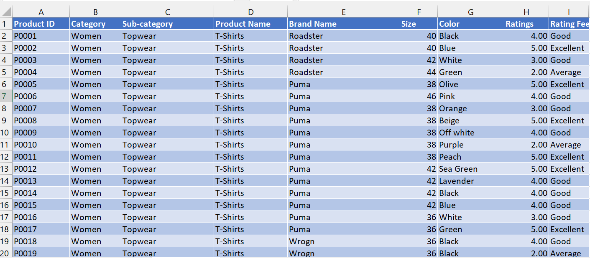

* Figure 2. :-

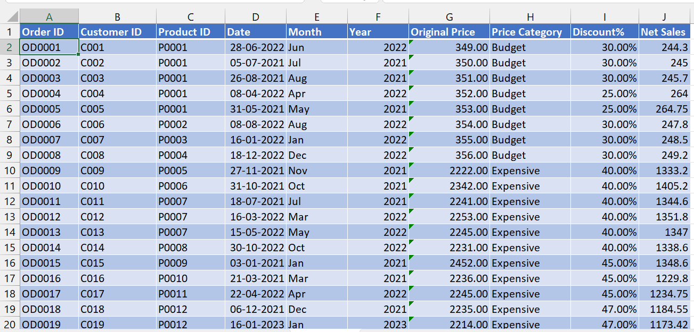

* Figure 3. :-

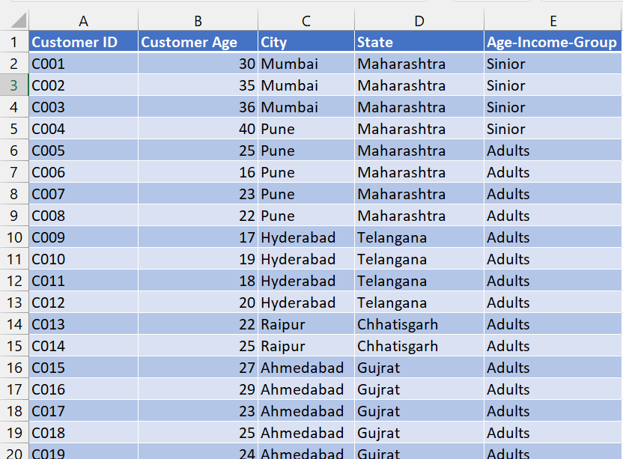

# Data Description: -

* Figure 1. :-

1. 1st column has product ID given to every product shipped e.g., P0001.
2. 2nd column has category of the products they deal with e.g., Women, man, kids, beauty products.
3. 3rd has the category of segments of products. E.g., top wear, footwear, bottom wear.
4. 4th column has the product name that are sold.
5. 5th column has the brand name of the product sold.
6. 6th column has the size of the product sold.
7. 7th column has the colour of the products sold.
8. 8th column has the rating given by customer to the product.

* Figure 2. :-

1. 1st column is of order id which is given to every order placed.
2. 2nd column has Customer ID of the customers starting from C001 to C100.
3. 3rd column has product ID given to every product shipped e.g., P0001.
4. 4th column has the date on which order was placed.
5. 5th column has the original price of the product ordered.
6. 6th column has the discount given on each product.

* Figure 3. :-

1. 1st column has Customer ID starting from C001 to C100.
2. 2nd column has customer ages.
3. 3rd column is of city from where orders were placed.
4. 4th column is of state from where orders were placed.

## Problem Solving - (Data Creation): -

1. **Sheet Name- fact_orders**

* **After analysing the data we added 3 columns that were essential for the easy understanding and processing of data.**
* **1st column we added was of month, where we sorted the data by the month in which the orders were placed using the formula =TEXT([@Date],”mmm”) which in return gave us the value of the month with respect Date column.**
* **2nd column we added was of Net Sales, in which we find the net sale after giving the discounts on products by using the formula , =Table3[@[Net Sales]].**
* **3rd column we added was of Sales, this if the find the value of the product after applying the discount by using the formula =Original Price- Original Price*Discount% .**

1. **Sheet Name- dim_Customers**

* **We added Age Group column to sort the different age customers into the specified range by using the formula =IFS([@[Customer Age]]<=15,"Child",[@[Customer Age]]>=30,"Sinior",[@[Customer Age]]<=30,"Adults")**

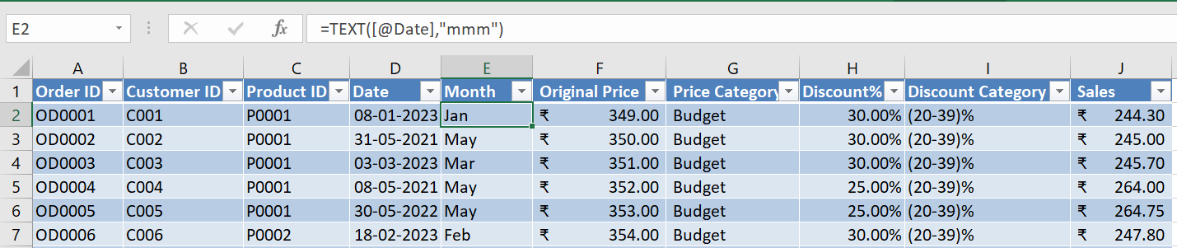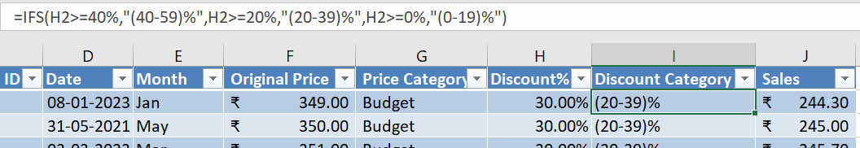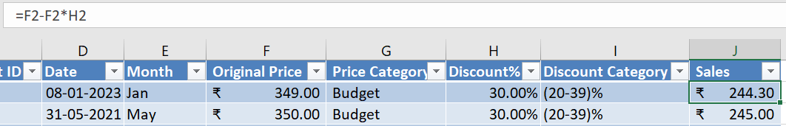

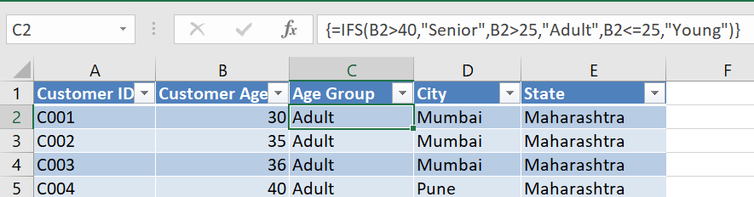

**3. After Uploading the 3 tables on Power Pivot we go the Diagram View on home and there we made the relationship between 3 tables. We connected Product ID from Table 1 and Table 2, and Customer ID from Table 2 and Table 3.**

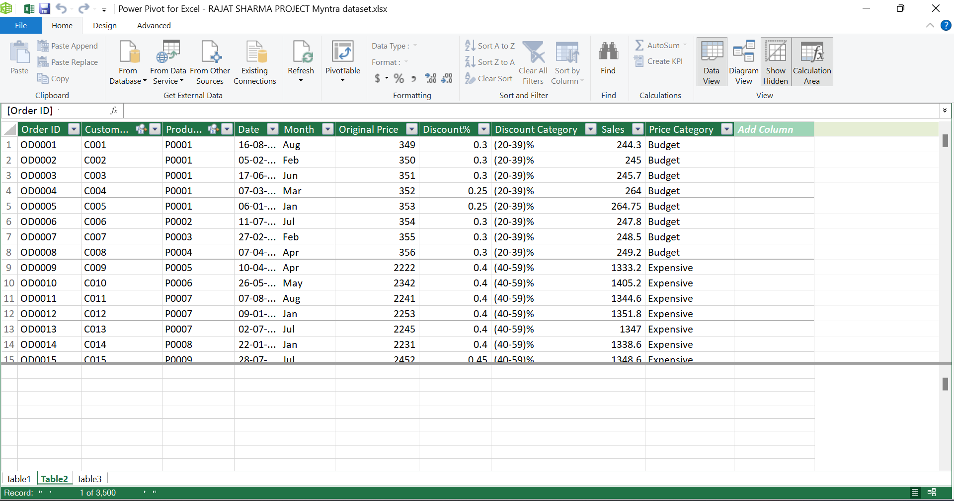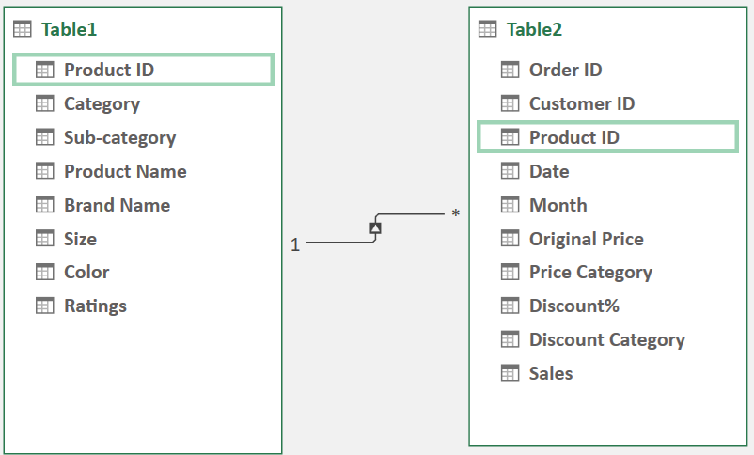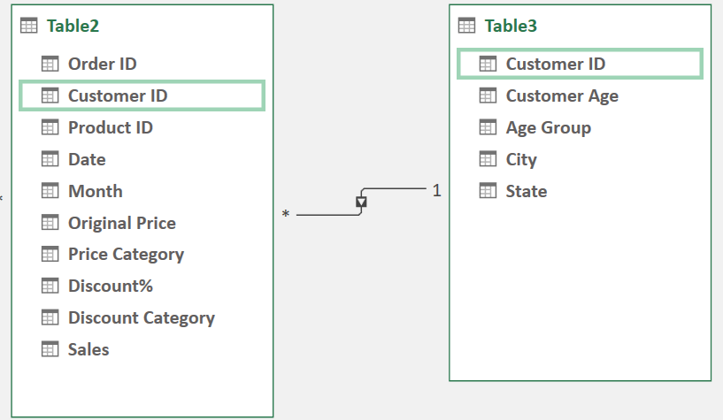

## Data Analysis by using the Power Pivot and Charts: -

**The chart on the last sheet is showing the month wise sales with number of orders for year 2021-2023.**

**Then we insert Timeline slicer to get the month wise sales of a specific year on the cart on the left.**

**For the year 2021, total sale is Rs. 787K with 1517 orders placed all together.**

**Highest sale month, September with Rs. 85K sales with 150 orders placed.**

**Lowest sale month, April with only Rs 49K sales with only 113 orders placed.**

**The Pie chart is showing the percentage share of the total sales by different age group where young (Below 25 Year) contributing to the 58% of the total sales, Adult (26-40 year) and Senior (Above 40 year) contributing 31% and 11% respectively.**

**The Pie chart is showing the ratings which gives by the customer on the behalf of Services, Product Qualities, Product Price etc.**

**The Pie chart is showing the percentage share of the total sales by different Price Category where Budget Products (1-1000rs) has the highest share with 73% of the total sales. With economy (1001-2000rs) and Expensive (2001-3000rs) having total sales share of 22% and 5% respectively. Whereas premium (above 3000rs) products only contribute to 0% of the total sales.**

**The chart shows the total sales by each individual bands. With Puma having the highest sales of Rs.250K from 246 orders. H&M, Roadster, Adidas with Rs. 160K, 120K, 72K sales respectively.**

**The chart is showing the State wise sales comparison.**

**With top 5 states with the heights sales namely Gujrat with 296K sales, Uttar Pradesh with 266K and Punjab, Bihar, Rajasthan with 256K,231K,211K respectively.**

**These 3 states (Gujrat, Uttar Pradesh, Punjab) contribute to the 44% of the total sales.**

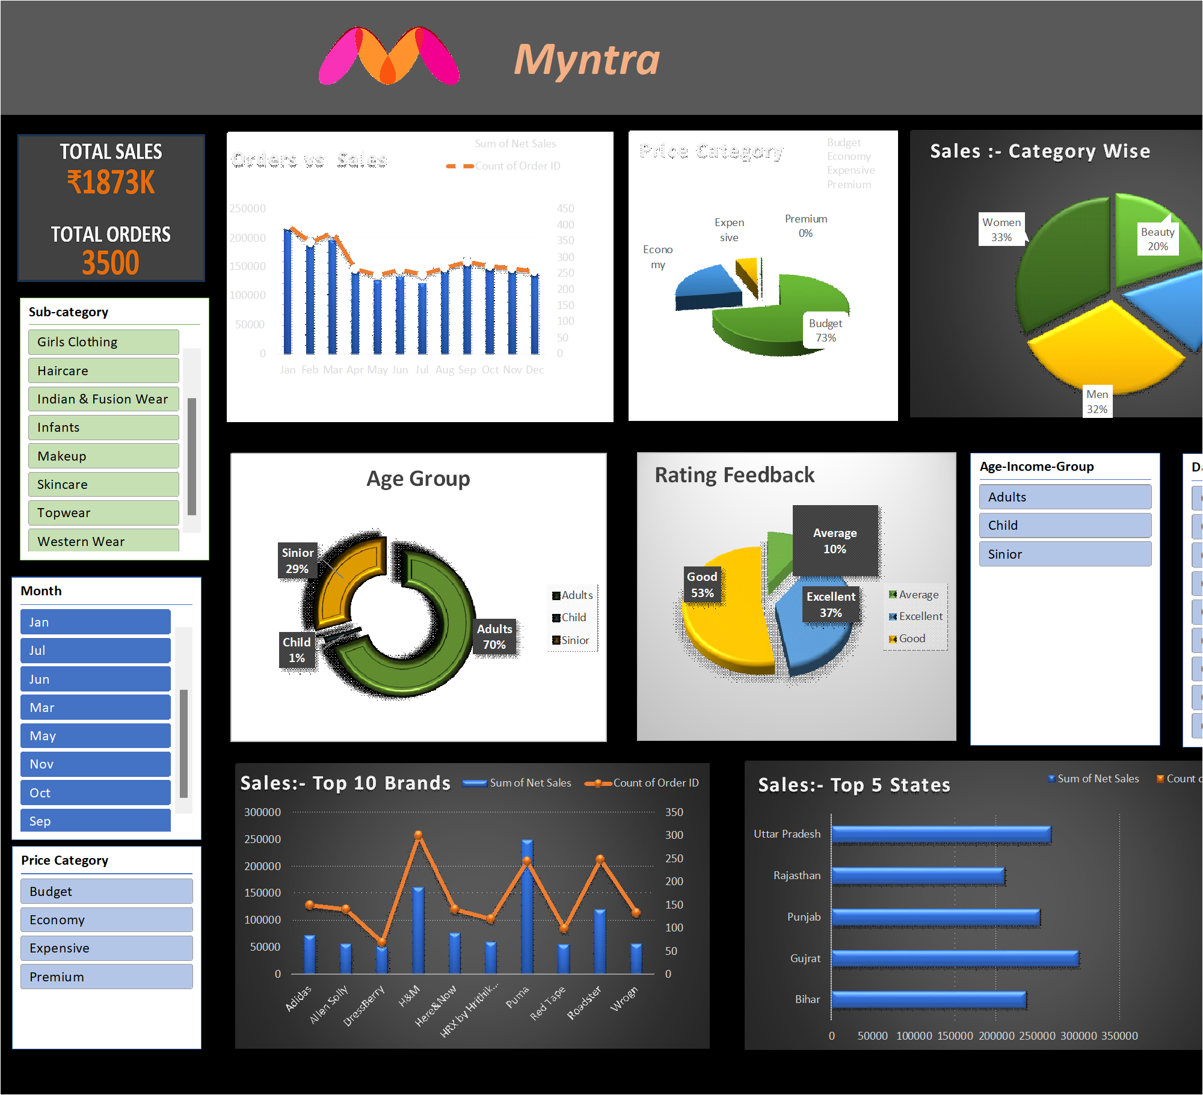

# INSIGHTS: -

* Young age group below 25years are maximum contributing to the sales about 58%.
* Men and Women category products contribute to 60% of the sales.
* Budget (below Rs. 1001) Price Category contributing 48% of the total sales.
* These 3 states (Gujrat, Uttar Pradesh, Punjab) contribute to the 44% of the total sales.
* There is 10% increase in sales in 2022 compare to 2021.
* (20-39) % discount range contribute to the 56% of the total sales.
* Top 5 brands (Puma, H&M, Roadster, Adidas, Allen Solley) contribute 36% of the total sales.

# Final Conclusion to improve Myntra sales: -

* Target young customers below the age of 25 living in Gujrat, Uttar Pradesh, Punjab with the budget products of the top 5 brands pricing below Rs. 1000 and with the Discount ranging between (20 – 39) % or with other special offers and coupons.